# Technical Design Document: Programming Exercise 6

# Name: Lucas Korzeniewski
# Date: June 28, 2026
# Program Description: This program uses regular expressions to validate three types of user input: a phone number, a Social Security number (SSN), and a ZIP code. The program prompts the user to enter each value, checks whether the input matches the required format, and displays whether the input is valid or invalid.
## Function: validate_phone(phone_number)
Validates that the phone number is entered in the format
(123) 456-7890
Parameters:
phone_number (string): The phone number entered by the user.
Variables:
None
Logic:
- Compare the phone number to the phone number regular expression.
- Determine whether the entire string matches the required format.
- Return the validation result.
Return:
Returns True if the phone number is valid; otherwise, returns False

## Function: validate_ssn(ssn)
Validates that the Social Security number is entered in the format
123-45-6789.
Parameters:
ssn (string): The Social Security number entered by the user.
Variables:
None
Logic:
- Compare the Social Security number to the SSN regular expression.
- Determine whether the entire string matches the required format.
- Return the validation result.
Return:
Returns True if the Social Security number is valid; otherwise, returns False.

## Function: validate_zip(zip_code)
Validates that the ZIP code is entered in either the 12345 or
12345-6789 format.
Parameters:
zip_code (string): The ZIP code entered by the user.
Variables:
None
Logic:
- Compare the ZIP code to the ZIP code regular expression.
- Determine whether the entire string matches an accepted format.
- Return the validation result.
Return:
Returns True if the ZIP code is valid; otherwise, returns False.

## Function: main()
Prompts the user to enter a phone number, Social Security number, and
ZIP code. Calls the appropriate validation function for each input and
displays whether each value is valid or invalid.
Parameters:
None
Variables:
phone_number (string): Stores the phone number entered by the user.
ssn (string): Stores the Social Security number entered by the user.
zip_code (string): Stores the ZIP code entered by the user.
Logic:
- Prompt the user to enter a phone number.
- Call validate_phone().
- Display whether the phone number is valid or invalid.
- Prompt the user to enter a Social Security number.
- Call validate_ssn().
- Display whether the Social Security number is valid or invalid.
- Prompt the user to enter a ZIP code.
- Call validate_zip().
- Display whether the ZIP code is valid or invalid.
Return:
None

#Link to your repository: https://github.com/lucask333?tab=repositories
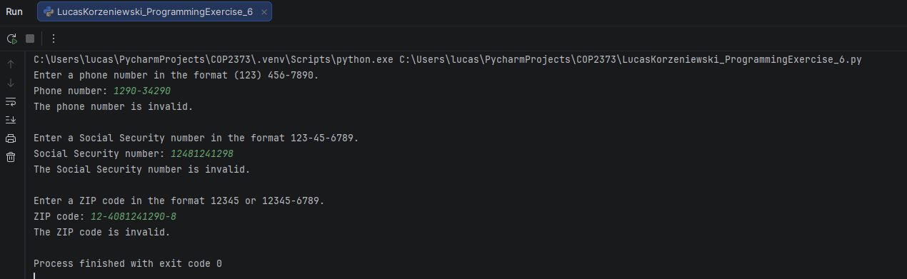
Output Screenshot: (make sure big enough so I can see)

